
Follow us:
Dummy Address
Lorem Ipsum Sit Amet Dummy Pin Dummy place. Telephone : 1-800-123-4567. Email : info@dummy.com ...
Tagline
Company Name

Provide a service to help businesses and people connect developed and Nhege Solutions was formed.
Our Vision
Our goal is to provide challenging and rewarding work atmospheres to help them reach their personal goals, while treating them fairly, honestly and with respect. Nhege Solutions strives to provide top notch service.
We focus on making positive changes for our clients’ businesses and our employees’ lives through dedication to the process of hiring and service.
us
About

Stats
Our campaign increases the traffic since advertisements were released. We inspire by a culture of curiosity and a freedom of exploration.
3M Followers
2M Followers
3M Followers
6M Followers
Media Atendees
Vendors & Exhibitors
Website Visitors
Social Media Followers
10 000+
20 000+
500 000+
200 000+
The
Visitors
Traffic
Increase
Popularity
Increase
75%
65%
Social
Media
Followers
Trending
in Social
Media
Almost 46% of your visitors will judge the credibility of your organization based on the design of your website
Building your business through the web starts with custom website design. But with more than 80% of clicks happening on the first page of Google Search, a professional search engine marketing strategy is a must.
will help you differentiate yourself from competitors through cohesive business branding efforts, both on- and offline. From logo design, to professional copywriting and website messaging,
During the Development Phase, we’ll create a development environment for your work-in-progress website so you can monitor our progress in real-time, while having an available test environment for your website training. This is just one of the many ways we approach websites
Let our creative marketing professionals help your business stand out from the crowd!.
Our award-winning design team
We are Google Certified Web Developers
in 2024.
Branding
Strategy
Web
Development
Services
Responsive
Web Design
Search Engine
Optimization
Don't see what you're looking for? Contact one of our online marketing specialists today, to learn more about how we can tailor a solution for you OR what we've got in the works!
We've got the answers to all your social media questions and an expert team to help you develop and execute your social media marketing campaigns. Our social media management services
We offer premium website design services for eCommerce online store websites. Our sites are designed to attract new customers, Deliver a satisfying shopping experience and streamlinedifferently.
Industry
Solutions
Social Media
Marketing
E-commerce
Websites
Professional
Websites
We’ve created over 800

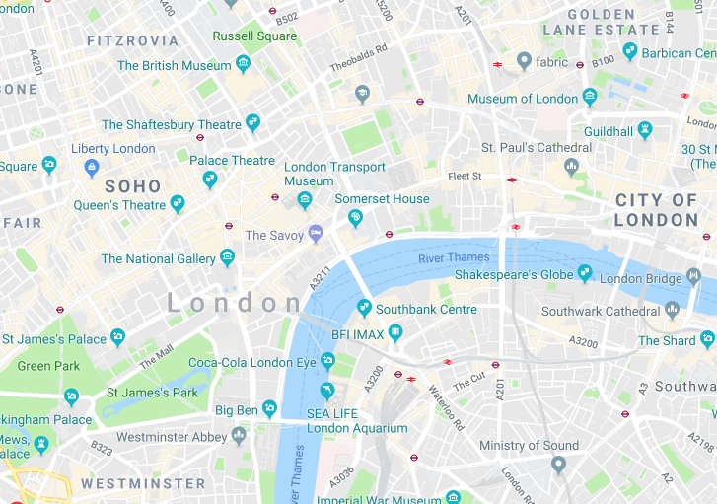
Contacts
Company Name
pinterest.com/companyname

twitter.com/companyname

instagram.com/companyname

fb.com/companyname
For client support services, please visit
nhegesolutions.com or email us at
support@companyname.com. For all
other inquiries, feel free to send us a
message or visit our main office now!

